Neha – M1040187

Assignment 3- lambda (python) function with URL parameters integrate with api gateway

Step 1:

Create Lambda function runtime as Python.

Add code(without param pass) in code editer and test after deploy.

We need to click on test button and set event name as test to excute.

Step 2 :

Update Lambda function code to pass user input:

Test by configuring json input as below in test configuration:

Step 3 :

Create API Gateway by choosing Rest API and Python as a language

Update API by clicking on Action button select “Create API” and Create Method “Any” select same, put Python function name “**fullName** and save.

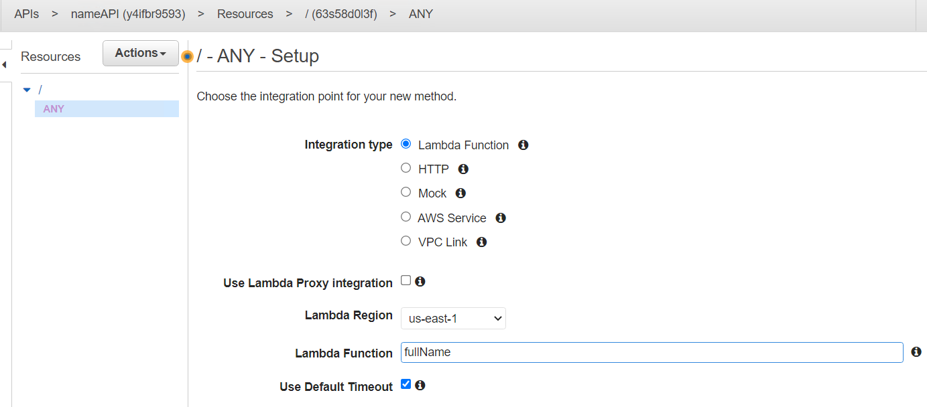

Step 4 :

Select Method Execution -> Method Request -> Add Query Param variables

Step 5 :

Select Method Execution -> Integration Request -> click Method Template put “application/json” as content type and pass Param Json as below

Step 6 :

Click on Action-> Deploy API and pass stage as “test” deploy. A new URL will be generated click on same.

When user is **not passing** required parameters ->

When user is **passing** required parameters ->

